Microorganisms Fact sheet

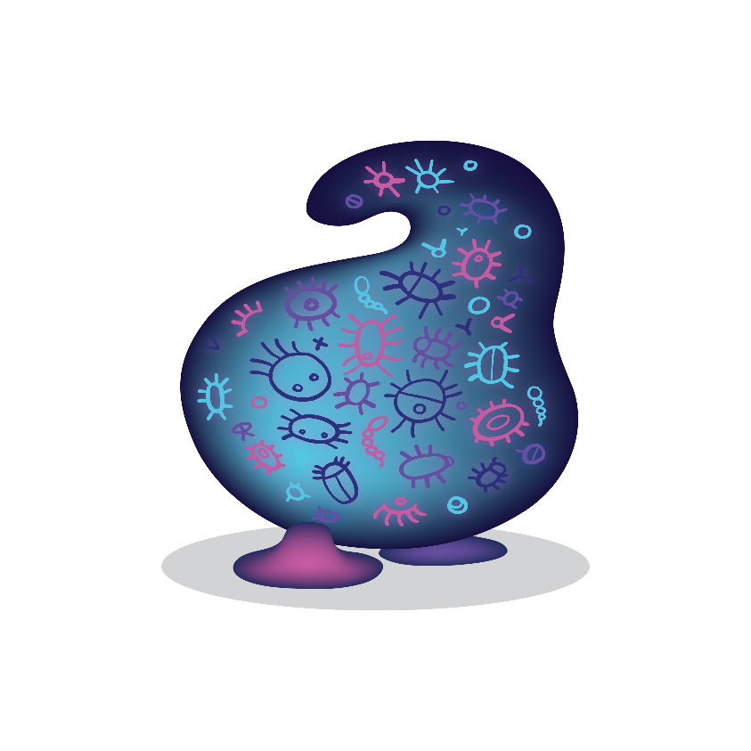

Microorganisms are small living things include microbes, viruses and fungi. Microbial pollution in waterways is unwanted organisms that can be harmful to human, animal or plant life. They can cause a variety of different diseases and illnesses such as salmonella poising or hepatitis A.

A typical source of microbial pollution is human or animal faecal matter that has been washed into creeks or rivers via heavy rains. Over flowing waste water treatment plants during heavy rain can be another source of microbial pollution.

## What you can do

Ensuring animal waste is picked up when walking the dog is one easy way stop microbe pollution

## Links

<https://healthywa.wa.gov.au/Articles/F_I/How-safe-are-natural-waterways>

<https://ww2.health.wa.gov.au/Articles/A_E/Bacterial-water-quality>

<http://www.goldcoast.qld.gov.au/documents/bf/healthy-waterways-brochure.pdf>